**Standard Software Systems Development Questions**

Mamdouh Zayed

Colorado State University Global

CSC505: Principles of Software Development

Dr. Pubali Banerjee

April 15, 2024

**Standard Software Systems Development Questions**

The key components and requirements in the assignment:

1. Python Script: I need to write a simple Python script.

2. Questions: I need to answer specific questions related to software development.

3. Requirements: I need to include screenshots of successful execution, related diagrams, and references.

4. Formatting: My document needs to follow CSU Global Writing Center requirements.

5. References: I need to include at least two scholarly references.

Python Script: I am creating a script called Online Shopping Cart. Here's the screenshots of the output:

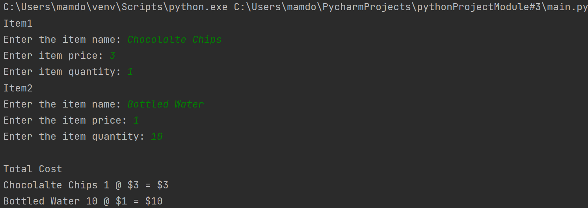

Following is the answer to all questions as provided in the question.

**Why does it take so long to get the software finished?**

Software development involves several complex steps, including planning, designing, coding, testing, and debugging. Each step requires careful consideration and time to ensure the final product is functional and reliable. Additionally, factors like changing requirements, unexpected issues, and the need for collaboration among team members contribute to the extended timeline (Clarke, 2020).

**Why are development costs so high?**

Development costs are high due to various factors, including the need for skilled personnel, tools, resources, and infrastructure. Additionally, changes in requirements during development can lead to increased costs. Ensuring software quality through rigorous testing and the expense of fixing errors also contribute to higher costs (Pressman & Maxim, n.d.).

**Why can't we find all the errors before we give the software to our customers?**

It's challenging to identify all errors before releasing software because of the complexity of modern systems (Langer, 2016). Testing can cover a wide range of scenarios, but it's impossible to anticipate every possible situation. Time and resource constraints might limit the depth of testing, and some errors may only surface under specific conditions that weren't foreseen.

**Why do we spend so much time and effort maintaining existing programs?**

Maintenance is essential to keep software functional, secure, and up to date. Technology is evolving, and software needs to adapt to new environments, requirements, and security threats (Langer, 2016). Additionally, user feedback and changing needs often necessitate updates and improvements, requiring ongoing effort.

**Why do we continue to have difficulty in measuring progress during software development and maintenance?**

Measuring progress is difficult because software development is a creative and iterative process (Pressman & Maxim, n.d.). Milestones might not correspond directly to visible features, and unexpected issues can arise. Additionally, changes in requirements, unforeseen challenges, and the need to balance progress with quality make it hard to define clear metrics.

**References**

Arthur M. Langer. (2016). *Guide to Software Development: Designing and Managing the Life Cycle: Vol.* Second edition. Springer*.*

Jill Clarke. (2020). Software Developer. BCS, The Chartered Institute for IT.

Pressman, R., & Maxim, B. (n.d.). Software Engineering. software-engineering-a-practitioners-approach-9nbsped-9781260548006-1259872971.